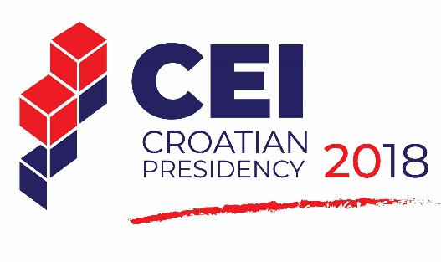
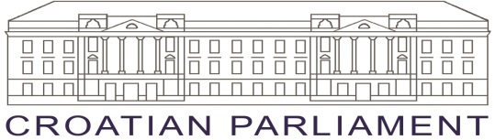

- -

CEI PD Parliamentary Committee Meeting
Zagreb, 13-14 May 2018

JOINT STATEMENT
The meeting of the Parliamentary Committee of the Parliamentary Dimension of the Central European Initiative was held in Zagreb on 14th May 2018 under the chairmanship of the President of the PD CEI Mr Peđa Grbin.
The meeting was attended by the parliamentary delegations of Austria, Belarus, Bosnia and Herzegovina, Bulgaria, Croatia, Czech Republic, Hungary, Italy, Macedonia, Montenegro, Poland, Romania, Serbia, Slovakia and Ukraine.
After exchanging views on the challenges of sustainable tourism, the participants issued the following Joint Statement:
***
Guided by the European Charter for Sustainable and Responsible Tourism, the European Commission’s Consultation Document, the Conclusions and Recommendations of the 2014 European Inter-Parliamentary Conference: “Challenges of Sustainable Tourism: Promoting Cultural Heritage and Environment Protection”;
Aware of the great importance of strengthening the cooperation between tourism and other sectors, including economy, environment protection and culture;
Having in mind that regional cooperation plays a crucial role in the development of tourism;
Recognizing that numerous sustainable tourism initiatives, particularly in tourism infrastructure, have proved to be financially and socially viable in the long run;
Emphasizing the importance of a balanced approach to economic, social, cultural and environmental aspects of sustainability;
Welcoming the fact that sustainable tourism is dealt with by many various EU bodies and promoted by some of the 2020 Strategy flagship initiatives, namely the ones related to resource efficiency, innovation, youth, digital agenda and job creation;
Remarking with pleasure that since the two past years European institutions have been expressing a better engagement for an higher integration of Western Balkans in the EU context encourage the EU Parliament, Commission and Council to continue to implement this new policy. At the same time recognize the important steps forward of non EU Western Balkans countries on their way to Europe and encourage them to continue to implement reforms
Confirming that sustainable tourism provides, both directly and indirectly, a market for goods and services in a wide range of sectors, such as transport, retailing, construction, culture, sports, food processing, fishing and agriculture;
We, the participants of the meeting of the Parliamentary Committee of the Parliamentary Dimension of the Central European Initiative held in Zagreb on 14th May 2018,
Invite national parliaments and governments to take into consideration the great importance of strengthening cross-sectoral cooperation between tourism and culture when proposing and implementing legislative initiatives;
Recommend all member states to make efforts that will allow maximum use of the resources provided in the EU funds, while the countries that are in the process of negotiations on EU membership are recommended to timely prepare for the use of these development opportunities, including through an active participation to the existing macro-regional strategies of the EU;
Welcome inter-parliamentary conferences and international fora as important tools for coordinating development policies and exchanging best practices in tackling the challenges of sustainable tourism within the European community;
Encourage all member states to develop their national tourism strategies responsibly in the long term perspective having in mind the needs of society;
Underline that business development should go hand in hand with the development of the local area and the local community, taking into account their history, cultural heritage, natural landscapes and resources, challenges of climate change and changes in the trends of tourist behaviour and habits;
Call on member states to safeguard and promote their heritage (natural, traditional, culinary, linguistic, historical, architectural, cultural etc.) as a platform for launching new and responsible entrepreneurial initiatives;
Highlight the importance of taking a balanced approach to economic, social, cultural and environmental aspects of sustainability that should be ensured by preserving cultural and natural resources, including biodiversity, as well as the importance of fostering social equity in the pursuit of economic competitiveness;
Acknowledge that tourism can develop more successfully when founded on common and harmonized policies, cross-border projects and regional initiatives aimed at facilitating sustainable tourism, but also sustainable development as a whole.

